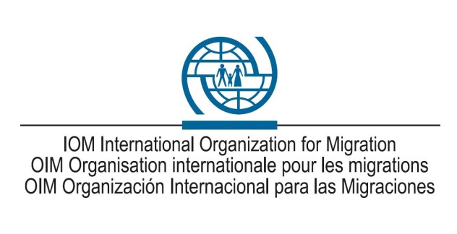
Annex: Terms of Reference

I. Position Information
Position title  Position grade  Duty station | Administrative Assistant  G4-S1  San José, Costa Rica
Appointment type | Special Short Term
Position rated on | Step 1
Reports directly to | Coordinator, CANVAC

Vacancy-specific information
Estimated closing date | 27.05.2022
Estimated start date | 10.06.2022

Posting channel

Complete WBS (up to the 5th level)

II. Organizational Context and Scope
Under the general oversight of the Immigration & Border Management (IBM) Division’s Immigration & Visa Support Solutions (IVSS) Unit at HQ and reporting directly to the regional VAC Team Leader programmatically and directly to the Chief of Mission administratively, the Incumbent will be responsible for providing effective and efficient administrative support for the Canadian Visa Application Centre in San José, Costa Rica operated by IOM; particularly s/he will:

III. Responsibilities and Accountabilities
- Provide client service excellence to applicants at all times, in full compliance with the IOM VFS Global agreement, the CIC Statement of Work (SOW) and the CIC Service Standards.
- Assist in the provision of client information: distribution of application forms, information sheets and checklists regarding visa requirements; assist with telephone, fax, e-mail, chat and SMS inquiries from clients (including requirements for submitting visa applications and the location of client’s passport), providing timely and accurate information to clients; marketing and providing assistance to clients with Value Added Services including but not limited to Self-Service and Assisted Data Entry services. Informing clients of any changes to visa requirements or submission procedures.
- Assist in the collection and forwarding of complete applications as per CIC checklists, including biometrics collection: provide guidance to clients on the proper completion of application forms, while reviewing and collecting same applications along with any supporting / additional documents, as required; record, dispatch and follow up on applications and passports; arrange appointments for visa applicants who require interview, as required.
- Collection of Fees: Where required, collect the applicable Canadian visa fee(s) and IOM service fee(s); issue accurate receipts; daily reconciliation of receipts and reporting same; Safe keeping of all applications, supporting documentation and fees collected and responsible for CANVAC office keys;
- Data Capture; Assist in maintaining a high degree of skill in using the CANVAC software platform provided; enter all applicant data, enroll biometrics as required, submit application documents in the required order, while forwarding all applicant, passport and appointment information to CIC; ensure accurate tracking of both applications and supporting documents via the CANVAC software’s bar code scanning system;
- Returning of passports, supporting documentation and visa decisions. Assist in collecting processed applications; returning processed applications, passports and supporting documentation;
- Reporting: Assist in maintaining accurate and detailed records of all applications and fees received, and biometrics enrolled and report these records daily;
- Maintain a professional appearance and migrant friendly demeanour at all times;
- Maintain positive working relationships with IOM’s Lead VAC Partner, VFS Global and CIC staff locally.
- Immediately inform management of any problems or issues related to her/his daily work and regularly make suggestions on how to improve efficiency and client service.
- Maintain positive working relationships with staff of the lead program partner, VFS Global.
- Comply with the IOM Policy for a Respectful Working Environment”, “IOM Confidentiality Agreement”, “IOM Data Protection Manual”, IOM Standards of Conduct”, and the “IOM Policy on Reporting Irregular Practices, Wrongdoing and Misconduct”.
- Such other duties as may be assigned by the IVSS/IBM Unit at HQ, the CoM/HoO and the regional Team Leader.

IV. Required Qualifications and Experience

Education
- University degree or equivalent in Business Management, Client Services, Social Science or related discipline preferred; or an equivalent combination of education, training & experience.

Experience
- Minimum 03 years of relevant professional experience in a similar setting & capacity preferred; Demonstrated ability to maintain accuracy & confidentiality in performing responsibilities
- Demonstrated proficiency with Microsoft Office applications, including Excel, PowerPoint, Good knowledge of information technology and proficiency in Microsoft Office applications especially Excel, Word, PowerPoint, Publisher, and SharePoint.
- Previous work experience in international organizations and companies would be an advantage.

V. Languages
Required |  | Advantageous
Fluency in Spanish and English is required.

VI. Competencies
The incumbent is expected to demonstrate the following competencies:
- Accountability – takes responsibility for action and manages constructive criticisms
- Client Orientation – works effectively well with client and stakeholders
- Continuous Learning – promotes continuous learning for self and others
- Communication – listens and communicates clearly, adapting delivery to the audience
- Creativity and Initiative – actively seeks new ways of improving programmes or services
- Leadership and Negotiation – develops effective partnerships with internal and external stakeholders;
- Performance Management – identify ways and implement actions to improve performance of self and others.
- Planning and Organizing - plans work, anticipates risks, and sets goals within area of responsibility;
- Professionalism - displays mastery of subject matter
- Teamwork – contributes to a collegial team environment; incorporates gender related needs, perspectives, concerns and promotes equal gender participation.
- Technological Awareness - displays awareness of relevant technological solutions;
- Resource Mobilization - works with internal and external stakeholders to meet resource needs of IOM ( optional depending on position level)

Submission of application:
The candidate should send his/her application through the following email cosanjosevacancies2@iom.int , using as Subject “SVN-2022-014 Administrative Assistant CVAC”.

The application must include:

- Curriculum with 3 references.
- Letter of interest.
- In case of receiving applications from foreigners living in Costa Rica, they must submit their work permit.
Candidates must submit their offer by July 01, 2022. No applications will be considered after this date. Shortlisted candidates will be invited to an interview.

Competencies should be drawn from the Competency Framework of the Organization.

